1. What is software? What is software engineering?

A: software: Software is a set of instructions, data or programs used to operate computers and execute specific tasks.

software engineering: Software Engineering is the process of designing, developing, testing, and maintaining software.

2. Explain types of software?

A. Types of software is :

1. Application software: application software is a computer software package that performs a specific function for user.

for example :Microsoft Office, Paint, Powerpoint and etc..

2. system software: system software is designed to run a computer's application programs. it coordinates activities and functions of hardware and software.

for example os , notepad and etc..

3. driver software: driver software also known as device driver.

Device drivers control the devices and peripherals connected to a computer,enabling them to perform their specific tasks.Every device that is connected to a computer needs at least one device driver to function.

for example: audio driver, video driver.

4. middleware: The term middleware describes software that mediates between application and system software or between two different kinds of application software.

For example, middleware enables Microsoft Windows to talk to Excel and word.

for example: database middleware,application server middleware.

5. programming software: this software use by programmer to write the code. it include assemblers, compilers, debuggers and interpreters.

for example: : Turbo c,Eclipse,Sublime etc.

3. What is SDLC? Explain each phase of SDLC?

A. Software Development Life Cycle (SDLC) is a process used by the software industry to design, develop and test high quality softwares.

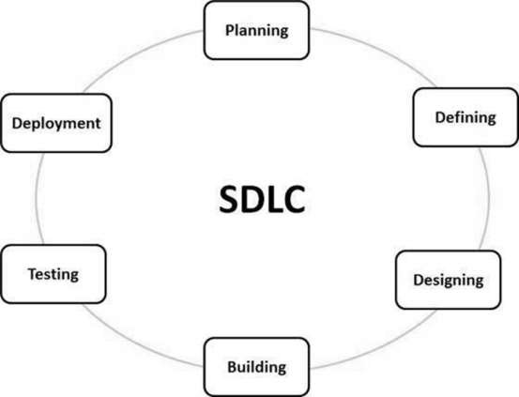

Stage 1: Planning and Requirement Analysis

Requirement analysis is the most important and fundamental stage in SDLC. It is performed by the senior members of the team with inputs from the customer, the sales department, market surveys and domain experts in the industry.

Stage 2: Defining Requirements

Once the requirement analysis is done the next step is to clearly define and document the product requirements and get them approved from the customer or the market analysts. This is done through an SRS (Software Requirement Specification) document which consists of all the product requirements to be designed and developed during the project life cycle.

Stage 3: Designing

A design approach clearly defines all the architectural modules of the product along with its communication and data flow representation with the external and third party modules (if any). The internal design of all the modules of the proposed architecture should be clearly defined with the minutest of the details in DDS.

Stage 4: Building

In this stage of SDLC the actual development starts and the product is built. The programming code is generated as per DDS during this stage. If the design is performed in a detailed and organized manner, code generation can be accomplished without much hassle.

Developers must follow the coding guidelines defined by their organization and programming tools like compilers, interpreters, debuggers, etc. are used to generate the code. Different high level programming languages such as C, C++, Pascal, Java and PHP are used for coding. The programming language is chosen with respect to the type of software being developed.

Stage 5: Testing

This stage is usually a subset of all the stages as in the modern SDLC models, the testing activities are mostly involved in all the stages of SDLC. However, this stage refers to the testing only stage of the product where product defects are reported, tracked, fixed and retested, until the product reaches

the quality standards defined in the SRS.

Stage 6: Maintenance

Once the product is tested and ready to be deployed it is released formally in the appropriate market. Sometimes product deployment happens in stages as per the business strategy of that organization. The product may first be released in a limited segment and tested in the real business environment (UAT- User acceptance testing).

Then based on the feedback, the product may be released as it is or with suggested enhancements in the targeting market segment. After the product is released in the market, its maintenance. 4. What is DFD? Create a DFD diagram on Flipkart.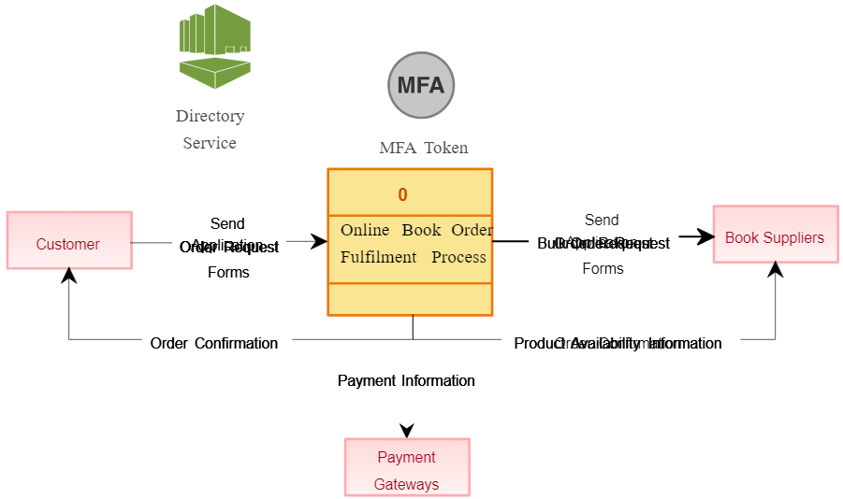

A. A data flow diagram is a graphical view of how data is processed in a system in terms of input and output. Data flow diagram (DFD) is a diagram being used frequently in software design. It visually represents the flow of data throughout processes in a given system.is done for the existing customer base.

5. What is Flowchart?Create a flowchart to make addition of two numbers.

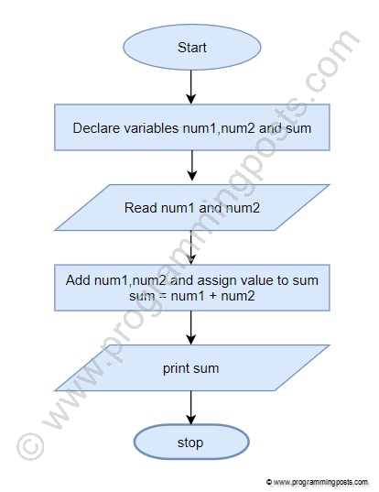

Flowchart is a graphical representation of an algorithm. Programmers often use it as a program-planning tool to solve a problem. It makes use of symbols which are connected among them to indicate the flow of information and processing.

6. What is Use case Diagram? Create a use-case on bill payment on paytm.

A.Use-case diagrams describe the high-level functions and scope of a system. These diagrams also identify the interactions between the system and its actors. The use cases and actors in use-case diagrams describe what the system does and how the actors use it, but not how the system operates internally.

